**Car Rental**

**Service**

**12/18/2019**

**CIS 3400-QMWA [55103]**

Linny Carolina Hiraldo Ramos

Role: System Analyst

[linnycarolina.hiraldoramos@baruch.cuny.edu](mailto:linnycarolina.hiraldoramos@baruch.cuny.edu)

Chhiring Sherpa

Role: Application Developer

[sherpac46@gmail.com](mailto:sherpac46@gmail.com)

Adrian Harris

Role: Documentation writer

[adrianharris890@gmail.c](mailto:adrianharris890@gmail.c)om

The purpose of our business is car rental services, with a high requirement for customer because we want to offer the best to our customers. In this moment the company has all the documents in paper and as we are growing we decide to create a database system that will make the service effective and reliable by reducing customer complaints and improve the quality of our services. Our business needs to keep track of customer information, types of cars and prices, employee information, and other. In our business we also appreciate our customer and we decide to make them offer or discount.

**Goals**

1. Create a database system
2. Improve services
3. Expand the services in different states

We may need to create a survey to understand customer needs. And review how we can adapt it to make some changes to the services.

### **Relationship sentences**

One **employee**   can take care of one or more **customers**

One **customer belongs to** one and only one employee

One **customer** can rent one or more car

One car belongs to one and only one customer

One customer can have one or more vehicles

One vehicle belongs to one and only one customer

One location can have one or more vehicles

One vehicle belongs to one and only one location

Initially our group thought that completing this project would be very daunting task because this is our first ever database class. However, our group worked as a team and helped each other thought out the entire project. The easiest part of this project was writing the business proposal and creating the ER model and the most difficult part was normalization and database implementation. As a group we learned how to create a simple functional database for small business. Overall, taking this class and working in this group project was very exciting and good learning experience.

**ERD**

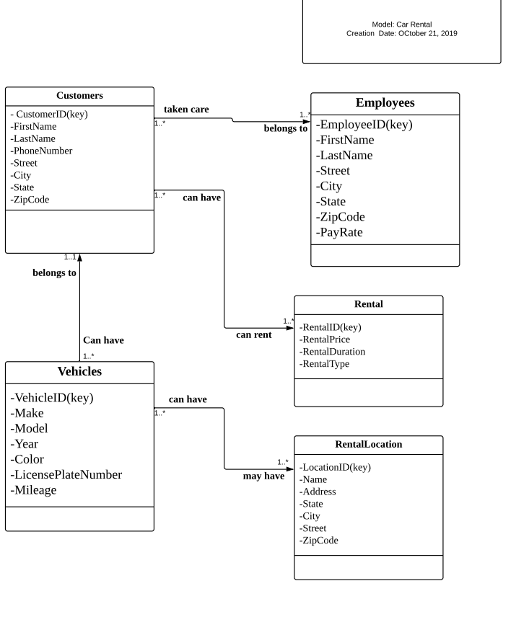

**Normalization of tables**

The goal of getting the tables normalized was to break the partial dependencies in the tables. There wasn’t a lot of partial dependencies to start with in this database.

1- **Customers**

Customers (CustomerID, First_Name, Last_Name, Phone_Number, Cust_Street,

Cust_City, Cust_State, Cust_ZipCode)

Key: CustomerID

FD1: CustomerID -&gt; First_Name, Last_Name, Phone_Number, Cust_Street, Cust_City,

Cust_State, Cust_ZipCode

FD2: CustomerID -&gt; First_Name, Last_Name, Phone_Number

FD3: Cust_ZipCode -&gt; Cust_City, Cust_State

2- **Employees**

Employees (EmployeeID, First_Name, Last_Name, Emp_Street, Emp_City, Emp_State,

Emp_ZipCode, Emp_PayRate)

Key: EmployeeID

FD1: EmployeeID -&gt; First_Name, Last_Name, Emp_Street, Emp_City, Emp_State,

Emp_ZipCode, Emp_PayRate

FD2: EmployeeID -&gt; First_Name, Last_Name, Emp_PayRate

FD3: Emp_ZipCode -&gt; Emp_City, Emp_State

3- **Rental**

Rental (RentalID, RentalPrice, RentalDuration, RentalType)

Key: RentalID

FD1: RentalID -&gt; RentalPrice, RentalDuration, RentalType

FD2: RentalID -&gt; RentalPrice, RentalDuration

4- **Vehicles**

Vehicles (VehicleID, Make, Model, Year, Color, LicensePlateNumber, Mileage)

Key:VehicleID

FD1: VehicleID -&gt; Make, Model, Year, Color, LicensePlateNumber, Mileage

**Code to create tables are:**

CREATE TABLE Customers

(

customer_ID VARCHAR(10) NOT NULL,

first_name VARCHAR(20) NOT NULL,

last_name VARCHAR(20) NOT NULL,

phone_number NUMBER,

cust_street VARCHAR(10),

cust_city VARCHAR(20),

cust_state VARCHAR(2),

cust_zipcode VARCHAR(10),

rental_ID VARCHAR(10) NOT NULL

)

CREATE TABLE Employees

(

employee_ID VARCHAR(10) NOT NULL,

first_name VARCHAR(20) NOT NULL,

last_name VARCHAR(20) NOT NULL,

emp_street VARCHAR(10),

emp_city VARCHAR(20),

emp_state VARCHAR(2),

emp_zipcode VARCHAR(10),

emp_salary NUMBER

)

CREATE TABLE Rental

(

rental_ID VARCHAR(10) NOT NULL,

rental_price NUMBER NOT NULL,

rental_duration NUMBER,

rental_type VARCHAR(20)

)

CREATE TABLE Vehicle

(

vehicle_ID VARCHAR(10) NOT NULL,

make VARCHAR(20) NOT NULL,

model VARCHAR(20) NOT NULL,

year NUMBER,

color VARCHAR(10),

plate_number NUMBER,

mileage VARCHAR(15)

)

CREATE TABLE RentalLocation

(

location_ID VARCHAR(10) NOT NULL,

name VARCHAR(20),

address VARCHAR( 15),

loc_city VARCHAR(20),

loc_state VARCHAR(2),

loc_zipcode VARCHAR(10)

)

**Alter table:**

ALTER TABLE Customers

ADD CONSTRAINT pk_Customers

PRIMARY KEY (customer_ID)

ALTER TABLE Customers

ADD CONSTRAINT fk_rental

FOREIGN KEY (rental_ID)

REFERENCES rental (rental_ID)

ALTER TABLE Employees

ADD CONSTRAINT pk_Employees

PRIMARY KEY (employee_ID)

ALTER TABLE Rental

ADD CONSTRAINT pk_Rental

PRIMARY KEY (rental_ID)

ALTER TABLE Vehicle

ADD CONSTRAINT pk_Vehicle

PRIMARY KEY (vehicle_ID)

ALTER TABLE RentalLocation

ADD CONSTRAINT pk_RentalLocation

PRIMARY KEY (location_ID)

**Inserting values into table**

INSERT INTO Customers (customer_ID, first_name, last_name, phone_number, cust_street, cust_city, cust_state, cust_zipcode, rental_ID)

VALUES (10201, John, Smith, 342-294-2993, 15 Hillside st., New York, NY, 12332, R15201);

INSERT INTO Customers (customer_ID, first_name, last_name, phone_number, cust_street, cust_city, cust_state, cust_zipcode, rental_ID)

VALUES (10202, Marc, Williams, 342-294-5553, 278 Park st., New York, NY, 12434, R15201);

INSERT INTO Customers (customer_ID, first_name, last_name, phone_number, cust_street, cust_city, cust_state, cust_zipcode, rental_ID)

VALUES (10203, Chris, Miller, 342-294-7798, 432 Lexington ave., New York, NY, 15432, R15203);

INSERT INTO Customers (customer_ID, first_name, last_name, phone_number, cust_street, cust_city, cust_state, cust_zipcode, rental_ID)

VALUES (10204, Mary, Smith, 342-294-7773, 209 Broadway st., New York, NY, 10945, R15202);

INSERT INTO Customers (customer_ID, first_name, last_name, phone_number, cust_street, cust_city, cust_state, cust_zipcode, rental_ID)

VALUES (10205, Kris , tenoero, 516 -894-2133, 154 Clement Ave., Elmont , NY, 11003, R15203);

**Employee**

INSERT INTO Employee (employee_ID, first_name, last_name emp_street, emp_city, emp_state, emp_zipcode, emp_salary)

VALUES (1, Jim, Bob, 123 Hollow road, Queens, NY, 11365, 10,000);

INSERT INTO Employee (employee_ID, first_name, last_name emp_street, emp_city, emp_state, emp_zipcode, emp_salary)

VALUES (2, Tony, Long , 453 Bent street, Queens, NY, 11366, 15,000);

INSERT INTO Employee (employee_ID, first_name, last_name emp_street, emp_city, emp_state, emp_zipcode, emp_salary)

VALUES (3, Johnny, Long , 563 Bent street, Queens, NY, 11366, 15,000);

INSERT INTO Employee (employee_ID, first_name, last_name emp_street, emp_city, emp_state, emp_zipcode, emp_salary)

VALUES (4, Justin, Long , 563 Bent street, Queens, NY, 11366, 15,000);

INSERT INTO Employee (employee_ID, first_name, last_name emp_street, emp_city, emp_state, emp_zipcode, emp_salary)

VALUES (5, Steve, Fries , 234-34 Street , Brooklyn, NY, 11203, 30,000);

**Rental**

INSERT INTO Rental (rental_ID, rental_price, rental_duration, rental_type)

VALUES (R15201, 2000, 30, Full-size);

INSERT INTO Rental (rental_ID, rental_price, rental_duration, rental_type)

VALUES (R15203, 3000, 30, Compact);

INSERT INTO Rental (rental_ID, rental_price, rental_duration, rental_type)

VALUES (R15202, 4000, 60, Economy);

INSERT INTO Rental (rental_ID, rental_price, rental_duration, rental_type)

VALUES (R15204, 5000, 90, Full-size);

INSERT INTO Rental (rental_ID, rental_price, rental_duration, rental_type)

VALUES R15205, 2400, 90, Compact);

**Vehicle**

INSERT INTO Vehicle (vehicle_ID, make, model, year, color, plate_number, mileage)

VALUES(20, Acura, 230, 2019, black, HBX3400, 3000);

INSERT INTO Vehicle (vehicle_ID, make, model, year, color, plate_number, mileage)

VALUES(30, Audi, Q5 , 2017, red, GFS3000, 100);

INSERT INTO Vehicle (vehicle_ID, make, model, year, color, plate_number, mileage)

VALUES(40, Benz, c240 , 2005, Grey, CFU5312, 120000);

INSERT INTO Vehicle (vehicle_ID, make, model, year, color, plate_number, mileage)

VALUES(50, Jeep, GrandCherokee, ,2007, Grey, XRX4200, 9201);

INSERT INTO Vehicle (vehicle_ID, make, model, year, color, plate_number, mileage)

VALUES(60, Lexus, Rx350, 2020, Blue, FUG1290, 20);

INSERT INTO Vehicle (vehicle_ID, make, model, year, color, plate_number, mileage)

VALUES(70, Nissan, Rogue, 2009, Black, MAK1048, 10000);

**RentalLocation**

INSERT INTO RentalLocation (location_ID, name, address, loc_city, loc_state, loc_zipcode)

VALUES(1, RentalLocationMan, 31 Lexington Ave, Manhattan, NY, 10004);

INSERT INTO RentalLocation (location_ID, name, address, loc_city, loc_state, loc_zipcode)

VALUES(2, RentalLocationBrook, 8th Street, Brooklyn, NY, 11223);

INSERT INTO RentalLocation (location_ID, name, address, loc_city, loc_state, loc_zipcode)

VALUES(3, RentalLocationQueens, 242-41st Bell Blvd, Queens, NY, 11354);

INSERT INTO RentalLocation (location_ID, name, address, loc_city, loc_state, loc_zipcode)

VALUES(4, RentalLocationBronx, 23st, Bronx, NY, 10453);

INSERT INTO RentalLocation (location_ID, name, address, loc_city, loc_state, loc_zipcode)

VALUES(5, RentalLocationStat, Freehold Ave., StatenIsland, NY, 10302);

**Database**

**Employees table**

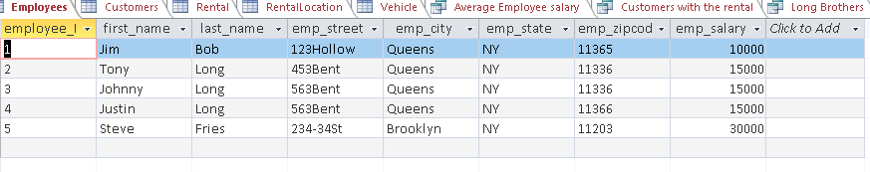

**Customers Table**

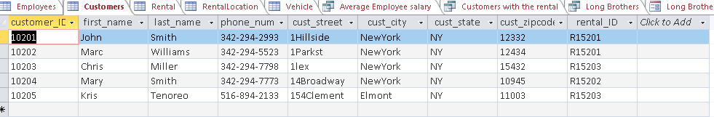

**Rental table**

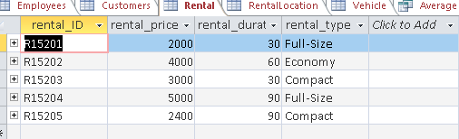

**Rental Location Table**

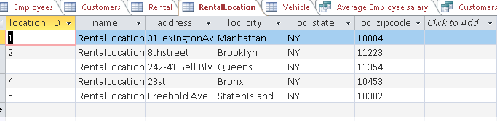

**Vehicle Table**

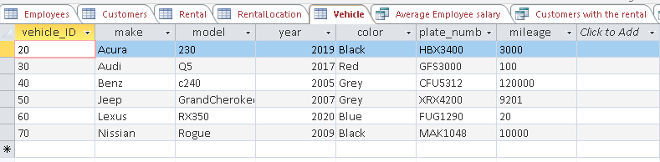

**Average Salary of Employees**

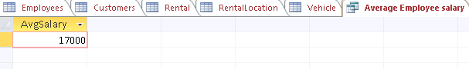

SELECT Avg(emp_salary) AS AvgSalary

FROM Employees;

**Customers with the same type of rental**

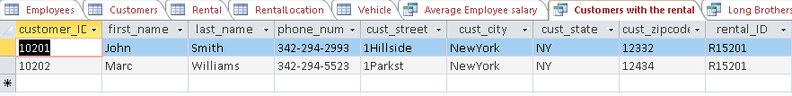



**The Long Brothers**

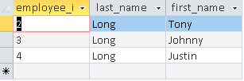



**Conclusion**

This project was a challenging one for us. Databases was a completely new topic for us. The most difficult part of this project was normalizing the tables and then coding them in Access. The easiest part of the assignment that wasn’t so easy was the coming up with the idea of for the project. This took the least time. Learning how to code in SQL and creating a live database was the best part of this assignment. If we could do this over again we would come up with an idea that was more tailored to our knowledge of databases. Looking in hindsight of this project the knowledge the knowledge we possess at the end of the semester is far more than the beginning of the semester. This would be a smoother process if the project was given at the end with our knowledge of databases at the peak